UNEMPLOYMENT INSURANCE FUND

1 April 2020

RE: MOA

To whom it may concern,

I, Mr LB Geldenhuys with ID Number 550713 5017 084, Managing Director of Agrigel (PTY) Ltd., hereby declare that we have less than 10 employees, therefore a MOA is not required for our claim with the UIF.

Should you have any queries, or require more information in this regard, please feel free to contact me on 013 668 0000.

Yours faithfully,

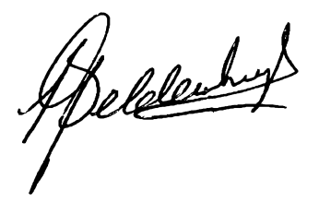
LEON GELDENHUYS
Managing Director

