UNEMPLOYMENT INSURANCE FUND

1 April 2020

RE: Letter of Authority

To whom it may concern,

I, Mr LB Geldenhuys with ID Number 550713 5017 084, Managing Director of Agrigel (PTY) Ltd., herein after referred to as the company, hereby grant permission to Mrs Nicole L Potgieter with ID Number 850514 0150 087, to lodge a claim with the Unemployment Insurance Fund on behalf of the company.

Should you have any queries, or require more information in this regard, please feel free to contact me on 013 668 0000.

Yours faithfully,

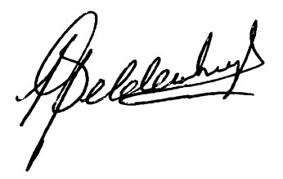
LEON GELDENHUYS
Managing Director

