2 Kippin Close
Redlynch Valley
Cairns
4870
Queensland
Australia

04 March 2015

To Whom it may Concern,

RE: Proof of residence

I A.N. Geldenhuys, ID No 5705265003086 resident at the above address being the owner of the residence at 12 Smit Street Delmas do hereby declare that my brother has occupational rights and is living there.

Yours faithfully,
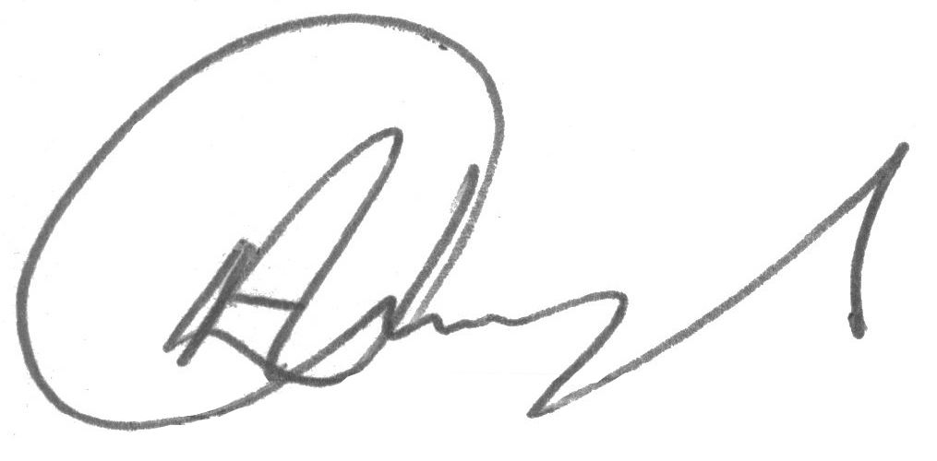
A.N. Geldenhuys

